Grade 7 Accelerated · Unit 4  Reference Sheet  Solving Problems with Rational Numbers — keep this in your binder | Name______________________  Date______________________  Period____________________

Everything on this page is tested from memory. The Grade 8 FAST reference sheet lists no rule for operating in scientific notation, nothing about significant digits, and no order of operations; what it gives you is an on-screen scientific calculator, which will happily give you twelve digits of an answer that deserves two.
1. Operations in Scientific Notation Lessons 1–3 · the powers must match to add, never to multiply
Adding and subtracting: the powers of ten must match first. A power of ten is a place value, and you can only add things of the same size. Rewrite one number so both carry the same power, then add or subtract the coefficients and copy the power down.
 | Add or subtract | Multiply or divide
Must the powers match? | Yes — rewrite one first | No. They can be as far apart as they like
What happens to the coefficients | add or subtract them | multiply or divide them
What happens to the exponents | nothing — the power is copied down | add them (product) or subtract them, top minus bottom (quotient)
The exponents may be | no more than 2 apart | as far apart as they like

The exponents are never added when you add. 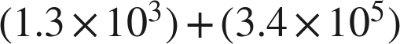 is not 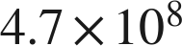. Ten to the fifth plus ten to the third is not a power of ten at all.
Every answer ends with a coefficient at least 1 and less than 10. If it is over 10, move the point one place left and raise the exponent: . If it is under 1, move the point one place right and lower the exponent: .
Addition and subtraction are limited to exponents within 2 of each other. That is the benchmark's own rule, so a test item will never ask you to add 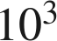 to 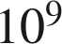. Multiplication and division have no such limit.
Moving the point and moving the exponent go opposite ways. Exponent up one, point one place left. The value never changes.
2. Significant Digits Lesson 4 · two rules, and it matters which one
Significant digits are the digits of a MEASUREMENT that carry information. A count is not a measurement: 24 students is exactly 24, and 60 seconds in a minute is exact, so neither ever limits an answer.
Rule | Example | Why
Every nonzero digit counts | 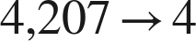 | they were all measured
A zero between nonzero digits counts | 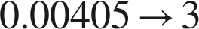 | it is holding a measured place
A leading zero never counts | 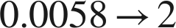 | it only locates the decimal point
A trailing zero counts, with a decimal point | 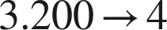 | writing it is a claim about thousandths
and does not count without one | 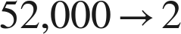 | those zeros only hold places

Two rules, and it matters which one you use. For a PRODUCT or a QUOTIENT, the answer takes the smaller of the two significant-digit counts. For a SUM or a DIFFERENCE, the answer stops at the leftmost place where either measurement's last digit sits.
The case where they disagree. 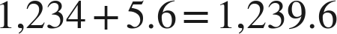. Counting digits would give 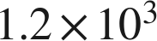 and throw away two digits that were measured; the place rule gives 1,240, which is right. Counting digits is the rule for products, and it belongs to products only.
Do all the arithmetic first and round once, at the end. Rounding in the middle moves the answer, and it keeps moving it every step afterwards.
In scientific notation, every digit you can see is significant. That is one of the reasons the notation exists: 52,000 is ambiguous, and 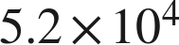 and 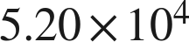 are not.
3. Radicals Lesson 5 · know both lists cold
The radical bar is a grouping symbol. Everything under it is finished before the root is taken. 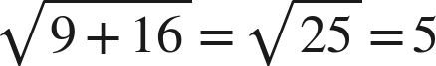 — never 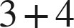.
Perfect squares to 225 | 1, 4, 9, 16, 25, 36, 49, 64, 81, 100, 121, 144, 169, 196, 225
Perfect cubes, −125 to 125 | −125, −64, −27, −8, −1, 0, 1, 8, 27, 64, 125

A square root sign gives the nonnegative root only. 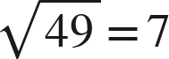, not −7 and not both, even though 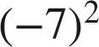 is also 49.
A cube root keeps the sign of what is under it. 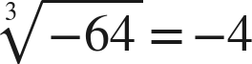. A cube root of a negative number is ordinary; a SQUARE root of a negative number is not a number you have. That difference is the one the state guide names most often.
Roots of fractions come apart. 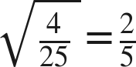 and 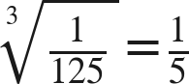 — top and bottom each get the root.
A root and a power in one expression: finish each piece, then combine. 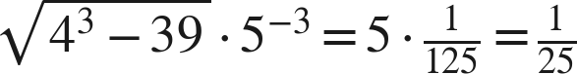.
4. The Order of Operations Lesson 6 · read the structure, not a mnemonic
There is no mnemonic here, and that is deliberate. A mnemonic has no letter for the radical bar or the fraction bar, and it makes people multiply before dividing. Read the expression and ask what is holding what.
Level | What | How
1 | Grouping symbols | ( ), [ ], the radical bar, the fraction bar — innermost first
2 | Powers and roots | the same level as each other
3 | Multiply and divide | left to right, as they come
4 | Add and subtract | left to right, as they come

Left to right means left to right. , not 2. , not 3. Nothing puts multiplication ahead of division or addition ahead of subtraction.
An exponent is attached to its own base, and parentheses decide what that base is. 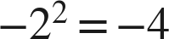 but 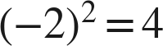. 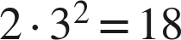, not 36.
A fraction bar is two grouping symbols at once. Finish the numerator, finish the denominator, then divide: 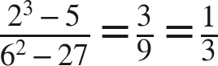.
5. Formulas and Word Problems Lessons 7–8 · substitute in parentheses; round last
Substitute in parentheses, every time. With 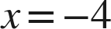,  is 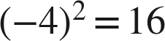. The parentheses keep the exponent attached to what it was attached to, and they keep a negative value negative.
There is no key word that tells you which operation to use. Two problems can carry the same numbers and the same words and need different operations. 15 dollars plus 4 dollars for each of 6 gigabytes is 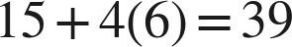; 15 dollars for each of 4 lines plus 6 dollars of tax is 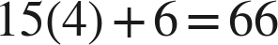. Circling and boxing gives the same markings on both.
A rate goes inside the parentheses that multiply the size; a flat fee stays outside. A square floor of side 9 feet at 2.89 dollars a square foot with a flat 95 dollars to install is 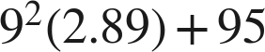, never 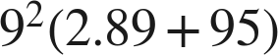.
Round once, at the end, and write the unit. Six sides of 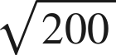 feet is 84.85 feet; rounding the side to 14 first gives 84 and loses most of a foot. An answer with no unit is not an answer to a real-world question.
6. Vocabulary
coefficient — the factor in 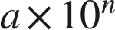; in a finished answer, 
significant digits — the digits of a measurement that carry information — every nonzero digit, every zero between them, and trailing zeros only with a decimal point
measurement — a quantity that was measured, so its last digit is uncertain; a count is not a measurement
precision — how far out a measurement's last digit sits. A sum or difference stops at the leftmost of the two
radical — a root symbol together with everything under its bar
radicand — the number under the radical bar; the bar groups it, so it is finished before the root is taken
principal square root — the nonnegative root that the square root sign names
grouping symbol — anything that holds part of an expression together and is finished first: ( ), [ ], the radical bar, the fraction bar
nested — one grouping symbol inside another; the innermost is finished first
formula — a rule written with letters that becomes a number once each letter is replaced by a value
substitute — replace a letter with its value, in parentheses
rate — a price or amount per unit of something — per square foot, per second — which multiplies the size; a flat fee does not

